Lecture 15: System & Magnitude Classes

Overview
- Shared Object Protocols
- Messages implemented for all objects
- 3 Classes
- Magnitude Classes
- Numbers & characters
- Collection Classes
- Lists, Arrays, and Dictionaries
- Streams
- Text, Files, and Sockets

Shared Object Protocols
- 3 messages that can be applied to an object relating to its class
- class finds out what class an object belongs to
- #(this is an array) class ← Array
- Similar to class are:
- isKindOf: aClass returns true if aClass is a parent class of the reciever
- #(this is an array) isKindOf: Collection ← true
- ismemberOf: aClass returns true if the receiver is an instance of aClass.
- #(this is an array) isMemberOf: Collection ← false
- isSequenceable returns Boolean value depending on whether the receiver is created from a subclass of SequenceableCollecetion
- #(this is an array) isSequenceable ← true.
- (Bag with: 'this' with: 'is' with: 'a' with: 'bag') isSequenceable ← false
- NOTE: class SequenceableCollection is called class IndexedCollection in smalltalk express, and isSequenceable is not available
- respondsToArithmetic: returns Boolean
- respondsToArthithmetic is implemented using the more general message, respondsTo: aSymbol, testing the symbols #+, #-, #*, and #/
- Comparing objects
- ==, ~~ CANNOT be overridden
- =, ~= CAN be overridden
- isNil, notNil
- Example: how to test and compare objects.
- Suppose we want to write a method that takes a set, and creates a dictionary. The dictionary stores the sorted list of members, the median, and the mean.

compileStats: aSet
|aDictionary sum setSize|
aDictionary := Dictionary new.
(aSet isKindOf: Set)
ifFalse: [self notify: 'warning, argument is not a kind of
class Set'. ^nil].
aSet class == SortedCollection
ifTrue: [ aDictionary at: 'Set' put: aSet]
ifFalse:
[ | aNewSet |
aNewSet := SortedCollection new.
aNewSet addAll: aSet.
aDictionary at: 'Set' put: aNewSet].
(aDictionary at: 'Set') do:
[:x | x respondsToArithmetic
ifFalse: [
self notify: 'Not numeric set'.
^nil]].
setSize := (aDictionary at: 'Set') size.
aDictionary at: 'median' put: ((aDictionary at: 'Set') at:
((setSize/2) rounded)).
sum := 0.
(aDictionary at: 'Set') do: [ :x | sum := sum + x].
aDictionary at: 'mean' put: ((sum/ setSize) asFloat).
^aDictionary.

- Set( 7, 12, 3, 9, 55) would result in the following dictionary
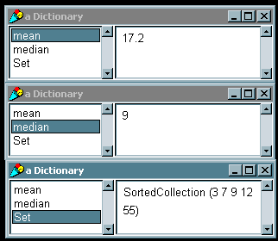

4 basic subclasses of the Magnitude class
- Char
- Similar to char in C, basic class can be treated similarly to number
- ArithmeticValue
- Superclass for all numerical classes
- Date
- Very different from C style of date & time, comparable and human readable
- Time
- Very different from C style of date & time, comparable and human readable

Methods provided for comparison
- aMagnitude between: oneMagnitude and: anotherMagnitude (range comparison)
- aMagnitude max: anotherMagnitude (max of the two magnitudes)
- aMagnitude min: anotherMagnitude (min of two magnitudes)
- aMagnitude hash
- <, <=, >, >=

Example: More methods for complex numbers
abs
“Returns the absolute value of a complex number”
^(self realPart squared + self imaginaryPart squared)sqrt

< aComplex
“Returns True if the reciever is less than aComplex”
aComplex isKindOf: Complex
ifTrue: [^self abs < aComplex abs]
ifFalse: [^self error: ‘Not a complex number’].

max: aComplex
“Returns the greater value of aComplex and the receiver”
self < aComplex
ifTrue: [^aComplex]
ifFalse: [^self].

= aComplex
“Returns True if the receiver is equal to aComplex”
aComplex isKindOf: Complex
ifTrue: [
^self realPart=aComplex realPart and: [
self imaginaryPart = aComplex imaginary part ]]
ifFalse: [^self error: ‘Not a complex number’]

hash
“hashes the absolute value of the reciver”
^self abs hash.

Partial Hierarchy

Type Conversion
- Converting to strings
- To produce a string representation of an object use:
- objectName printString

| aTruck |
aTruck := (Truck new) withSpeed: 5.
(aTruck printString) inspect.
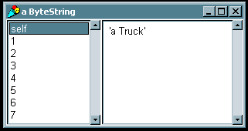

- objectName storeString

| aTruck |
aTruck := (Truck new) withSpeed: 5.
(aTruck storeString) inspect.
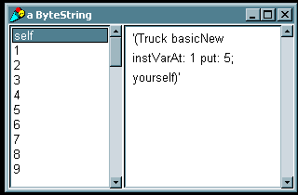

- To produce the string representation of a number, the above can be used, or more specialized methods may be used
- anInteger printStringRadix: aRadix (used for base aRadix representation)

| anInteger |
anInteger := 255.
(anInteger printStringRadix: 16) inspect.
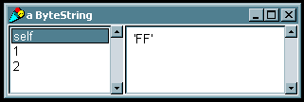

- anInteger storeStringRadix: aRadix

| anInteger |
anInteger := 255.
(anInteger storeStringRadix: 16) inspect.
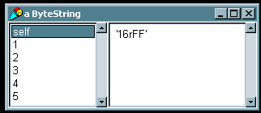

- Converting strings to numbers
- Requires streams to get strings from
- This topic will be discussed in a later lecture.
- Ex: Number readFrom: (ReadStream on: aStream)
- Type Conversion
- Conversion is automatic and transparent
- Conversion in direction integer -> fraction -> float to maintain accuracy
- To explicitly do conversion use following methods
- asInteger
- asFraction
- asRational in VisualWorks
- asFloat
- asCharacter (integers only)

| anInteger aFloat aList|
anInteger := 85.
aFloat := 3.25.
aList := List new.
aList add: anInteger asInteger.
aList add: anInteger asRational.
aList add: anInteger asFloat.
aList add: anInteger asCharacter.
aList add: aFloat asInteger.
aList add: aFloat asRational.
aList add: aFloat asFloat.
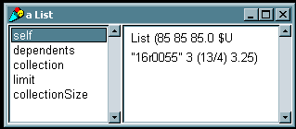aList inspect.

Truncation, floor, ceiling and remainders
- Truncation done through quo: method
- 11 quo: 5 => 2
- 11 quo: -5 => -2
- floor ceiling done though // operator
- 11 // 5 => 2
- 11 // -5 => -3
- ceiling done through \\ operator
- 11 \\ 5 => 3
- 11 \\ -5 => -2
- remainder is done through rem: method
- 11 rem: 5 => 1
- 11 rem: -5 => -1

Mathematical Operations
- Smalltalk provides basic subset of functions including
- Trigonometry functions: sin, cos, arcSin, arcCos
- Natural exponents and logarithms (exp and ln)
- Exponents and logarithms
- gcd and lcd
- Ex:
55 gcd: 30 ← 5
6 lcm: 10 ← 30
0.523599 sin ← 0.5
6 exp ← 403.429
2.718284 ln ← 1
6 raisedTo: 3 ← 216
25 log: 5 ← 2

Date and Time
- Simple protocol for referencing and converting times & dates
- Creating an time or date object
- Use now method for creating the current time
- currentTime := Time now.
- Use today method for creating the current date
- currentDate := Date today.
- You can create an object with both current date and time
- rightNow := Date dateAndTimeNow.
- rightNow := Time dateAndTimeNow
- Can create any time or date easily
- aDate := Date newDay: aDayOfTheYearInteger year: aYearInteger
- Time and Date Conversions
- Timing execution and delays
- Smalltalk provides a simple way to time the execution of a loop

| block1 block2 ms1 ms2 |
block1 := [100 timesRepeat: [Time now. Date today]].
ms1 := Time millisecondsToRun: block1.

block2 := [100 timesRepeat: [Time dateAndTimeNow]].
ms2 := Time millisecondsToRun: block2.

- Smalltalk includes a similar class Delay. The Delay class is useful for creating timers. Timers can be used to update clocks or send messages regularly.
- Delay should be used with the wait method
- The following shows a simple clock, which writes to the Transcript.

[[true] whileTrue:
[Transcript show: (Time now printString).
(Delay forSeconds: 1) wait]] fork.

Lecture 16: The Collection Classes

Smalltalk’s optimized Collection classes
- Unlike C, Smalltalk provides optimized classes for most types of collections
- There are three types of Collections
- Not keyed
- Example: Bag
- Keyed by integer
- Example: Array, List, OrderedCollection
- Keyed by value
- Example: Set, Dictionary
- For most situations, one of 5 types will suffice
- SortedCollection
- Sorts elements when inserted
- Example returns SortedCollection (‘a’ ‘b’ ‘c’)
| aSortedCollection |
aSortedCollection := SortedCollection new.
aSortedCollection add: 'c'.
aSortedCollection add: 'a'.
aSortedCollection add: 'b'.
aSortedCollection inspect.
- List
- Most flexible, keeps elements in the order in which they were added.
- Lists can be sorted.
- Elements can be inserted anywhere
- Example returns List ('a' 'b' 'c')
| aList aSortedList|
aList := List new.
aList add: ‘c’.
aList add: ‘b’.
aList add: ‘a’.
aSortedList := aList sort.

- Array
- Does not require adding, removing, or sorting elements
- Example returns #(‘d’ ‘b’ ‘c’)
| anArray |
anArray := Array new.
anArray at: 1 put: ‘a’.
anArray at: 2 put: ‘b’.
anArray at: 3 put: ‘c’.
anArray at: 1 put: ‘d’.

- Set
- Discards duplicate elements
- Does not support replacing elements
- Example
- aSet ← Set (‘a’ ‘b’)
- aList ← List (‘a’ ‘b’ ‘a’)

| aList aSet |
aList := List new.
aList add: 'a'.
aList add: 'b'.
aList add: 'a'.
aSet := Set new.
aSet addAll: aList.

- Dictionary
- New Concept to C programmers: Dictionary
- Otherwise known as Associated Hashtable
- Add keys and values, and reference values through keys
- Useful for global variables
- Possible to associate keys with any kind of object
- Ex:

| aThesaurus aCollection |
aCollection := Bag new.
aCollection add: 'big'.
aCollection add: 'enormous'.
aCollection add: 'huge'.
aThesaurus := Dictionary new.
aThesaurus at: 'large' put: aCollection.
aThesaurus at: 'small' put: 'little'.

Partial Hierarchy

Iteration (what you can do with collections)
- Iterate over a collection
- do: []
- Ex: (sum ← 15)
| sum aCollection |
aCollection := Bag new.
aCollection add: 3.
aCollection add: 5.
aCollection add: 7.
sum := 0.
aCollection do: [ :x | sum := sum + x].
- reverseDo: []
- Ex: (OrderedCollection(c b a) )
| aReverseCollection aOrderedCollection |
aOrderedCollection := OrderedCollection new.
aOrderedCollection add: #a.
aOrderedCollection add: #b.
aOrderedCollection add: #c.
aReverseCollection := OrderedCollection new.
aOrderedCollection reverseDo:
[:x | aReverseCollection add: x].

- collect: []
- Useful to Create new collections from existing ones
- Ex: (Bag(25 25 25… 0 0 0) )

| someIntegers someNumbers|
someNumbers := Bag new.
1 to: 25 by: 0.2 do: [ :x | someNumbers add: x].
someIntegers := Bag new.
someIntegers := someNumbers collect:
[ :x | x asInteger].

- Iterate over a collection and return a subset
- select: []
- Ex: (retuns only integers between 1 & 25 as floats)

| someIntegers someNumbers|
someNumbers := Bag new.
1 to: 25 by: 0.5 do: [ :x | someNumbers add: x].
someIntegers := Bag new.
someIntegers := someNumbers select:
[ :x | (x // 1) asFloat = x].

- reject: []
- Ex: (returns only integers between 1 & 25 as floats)

| someIntegers someNumbers|
someNumbers := Bag new.
1 to: 25 by: 0.5 do: [ :x | someNumbers add: x].
someIntegers := Bag new.
someIntegers := someNumbers reject:
[ :x | (x // 1) asFloat ~= x].

- Find occurrences of an object within the collection
- detect: []
- Ex: #(a 'abc' 3 4 5) detect: [:x | x isInteger]. ← 3
- Ex: #(a 'abc' 3 4 5) findFirst: [:x | x isFloat]
ifNone[nil] ← nil
- findFirst: []
- Ex: #(a 'abc' 3 4 5) findFirst: [:x | x isInteger]. ← 3
- findLast:
- Ex: #(a 'abc' 3 4 5) findLast: [:x | x isInteger]. ← 5
- Perform special operations
- inject: into: []
- For using temp variables and initializing them outside the block
- Ex: set the temp variable to 100
#(1 2 3) inject:100 into: [:x :y | x := x + y]. ← 106
- with: do: []
- takes one object from the receiver and one from the argument
- Ex: (result aBag= #( ‘aA’ ‘cC’))

| aBag |
aBag := Bag new.
#('a' 'b' 'c') with: #('A' 'Z' 'C') do:
[:x :y | x asUpperCase = y
ifTrue: [aBag add: (x,y)]].

Lecture 17: An example using the Collection Classes
- Matrices are not provided by the collection classes, but can be added very easily. We will demonstrate the Collection classes by creating a Matrix class.
- The class should provide methods to add, multiply, and transpose matrices and scalars together.
- The matrix will be represented in row-major order, through a collection of rows, where each row is an ordered collection. To accomplish this, the matrix needs only two variables to keep count on the number of rows and columns
- The Class definition is straight forward

OrderedCollection variableSubclass: #Matrix2D
instanceVariableNames: 'numrows numcols '
classVariableNames: ''
poolDictionaries: ''
category: 'Examples-Matrix2D'

"-- -- -- -- -- -- -- -- -- -- -- -- -- -- -- -- -- -- "!

Matrix2D
class instanceVariableNames: ''!

- The instance creation method creates a 2 dimensional matrix sized according to the arguments, and initializes all elements to 0.0. Note that the matrix is represented by aNumber1 OrderedCollections.

!Matrix2D class methodsFor: 'instance creation'!

rows: aNumber1 cols: aNumber2
"Creates a 2D matrix of size aNumber1 X aNumber2 and
initializes all elements to 0."

| matrix |
matrix := self new.
1 to: aNumber1 do: [ :i | | temp |
temp := OrderedCollection new.
1 to: aNumber2 do: [ :j | temp addLast: 0.0 ].
matrix addLast: temp ].
matrix setrows: aNumber1 cols: aNumber2.
^matrix! !

- The methods for accessing the matrix are straight forward as well, and are used only for getting elements and setting elements.

!Matrix2D methodsFor: 'accessing'!

at: anArray put: aNumber
"Place an element (aNumber) in the row and column
specified by anArray in the receiver."

(self at: (anArray at: 1)) at:(anArray at:2) put:aNumber.!

atRow: aNumber1
"Return an ordered collection from row aNumber1of the receiver."

^(self at: aNumber1).!

atRow: aNumber1 put: anOrderedCollection
"Puts an OrderedCollection into the matrix as a row.”

super at: aNumber1 put: anOrderedCollection.!

atRow: aNumber1 atCol: aNumber2
"Return an element from row aNumber1, column aNumber2
in the receiver."

^(self at: aNumber1) at: aNumber2.!

atRow: aNumber1 atCol: aNumber2 put: aNumber3
"Place an element (aNumber3) in row aNumber1, column aNumber2
in the receiver."

(self at: aNumber1) at: aNumber2 put: aNumber3.!

cols
"Returns the number of cols in the matrix."

^numcols.!

readAt: anArray
"Returns an element from the row and column
specified by anArray in the receiver."

^(self at: (anArray at: 1)) at:(anArray at:2).!

rows
"Returns the number of rows in the matrix."

^numrows.!

setrows: aNumber1 cols: aNumber2
"Sets the size of the matrix."

numrows := aNumber1.
numcols := aNumber2.! !

- To illustrate the access methods, we will create a 2x2 identity matrix with the code below. Recall an identity matrix is one which the top left to bottom right diagonal has 1 as the values of its elements, and all other values are 0.

| matrix1 |
matrix1 := Matrix2D rows: 2 cols: 2.
matrix1 at: #(1 1) put: 1.
matrix1 at: #(1 2) put: 0.
matrix1 at: #(2 1) put: 0.
matrix1 at: #(2 2) put: 1.
matrix1 writeToTranscript.
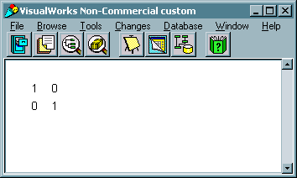

- The method writeToTranscript, as used above prints each row, an element at a time.

writeToTranscript
"Writes the matrix to the Transcript."

Transcript show: ' ';cr.
1 to: (self rows) do: [ :i |
Transcript show: ' '; tab.
1 to: (self cols) do: [ :j |
Transcript show:
(self atRow: i atCol: j) printString; tab.
].
Transcript show: ' ';cr.
].

- Although mathematical operations may appear to be complicated, the operations to be applied to the matrices are simple Collection manipulations.
- For the operation examples, the following matrices will be used. The code to create them is also shown below.

| matrix1 matrix2|
matrix1 := Matrix2D rows: 2 cols: 2.
matrix1 at: #(1 1) put: 1.
matrix1 at: #(1 2) put: 2.
matrix1 at: #(2 1) put: 3.
matrix1 at: #(2 2) put: 4.
Transcript show: 'Matrix1'.
matrix1 writeToTranscript.
matrix2 := Matrix2D rows: 2 cols: 2.
matrix2 at: #(1 1) put: 5.
matrix2 at: #(1 2) put: 6.
matrix2 at: #(2 1) put: 7.
matrix2 at: #(2 2) put: 8.
Transcript show: 'Matrix2'.
matrix2 writeToTranscript.
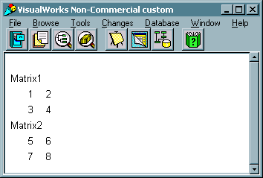
- matrixAdd: aMatrix adds aMatrix to the receiver and returns the sum of the two. A check is done to make sure both matrices are the same size

matrixAdd: aMatrix
"Adds the receiver and aMatrix, that is, Receiver + aMatrix."

| matrix |
( (numrows == ( aMatrix rows)) & (numcols == ( aMatrix cols)) )
ifFalse:
[ Transcript nextPutAll:
'matrixAdd - bad matrix size' ;endEntry.
^nil. ].
matrix := Matrix2D rows: numrows cols: numcols.
1 to: numrows do: [ :row |
1 to: numcols do: [ :col |
matrix atRow: row atCol: col put:
((self atRow: row atCol: col) +
(aMatrix atRow: row atCol: col)).
].
].
"Returns a new matrix"
^matrix

- Below is an example of adding two matrices.

Transcript show: 'matrix1 + matrix2'.
(matrix1 matrixAdd: matrix2) writeToTranscript.
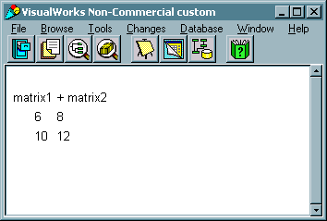

- matrixMult: aMatrix multiplies the receiver and aMatrix and returns the product. A check is done to make sure the number of rows in the receiver is equal to the number of columns in aMatrix (rule of matrix multiplication).
- $\begin{aligned} A=\begin{aligned}\left[A_{\text{11}} A_{\text{12}} … A_{1m} | \right]\left[A_{\text{21}} A_{\text{22}} … A_{2m} | \right]\left[⋮ | \right] \\ \end{aligned} \\ \end{aligned}$Recall the product of two matrices is as follows:

- The following code implements the equation above:

matrixMult: aMatrix
"Multiplies the receiver and aMatrix, that is, Receiver * aMatrix."

| nrows ncols matrix sum |
nrows := self rows.
ncols := self cols.
(ncols == ( aMatrix rows))
ifFalse: [ Transcript nextPutAll:
'matrixMult - bad matrix size' ;endEntry.
^nil. ].
matrix := Matrix2D rows: nrows cols:(aMatrix cols).

1 to: (aMatrix cols) do: [ :k |
1 to: nrows do: [ :i |
sum := 0.
1 to: ncols do: [ :j |
sum := sum + ((self atRow: i atCol: j) *
(aMatrix atRow: j atCol: k)).
].
matrix atRow: i atCol:k put: sum.
]
].
^matrix

- Below is an example of multiplying two matrices.

Transcript show: 'matrix1 * matrix2'.
(matrix1 matrixMult: matrix2) writeToTranscript.
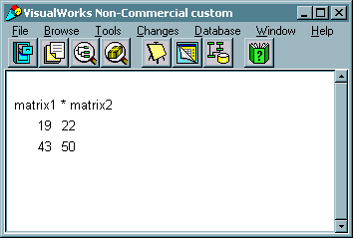
- The methods to add and multiply scalars are very similar to the matrixAdd: method, but even simpler.

scalarAdd: aNumber
"Adds aNumber to each element of the receiver."

| nrows ncols matrix |
nrows := self rows.
ncols := self cols.
matrix := Matrix2D rows: nrows cols: ncols.
1 to: nrows do: [ :row |
1 to: ncols do: [ :col |
matrix atRow: row atCol: col put:
( self atRow: row atCol: col ) + aNumber.
].
].
^matrix

scalarMult: aNumber
"Multiplies each element of the receiver by aNumber."

| nrows ncols matrix |
nrows := self rows.
ncols := self cols.
matrix := Matrix2D rows: nrows cols: ncols.
1 to: nrows do: [ :row |
1 to: ncols do: [ :col |
matrix atRow: row atCol: col put:
( self atRow: row atCol: col ) * aNumber.
].
].
^matrix

- Below is an example of multiplying a scalar and a matrix.

Transcript show: '3 * matrix1'.
(matrix1 scalarMult: 3) writeToTranscript.
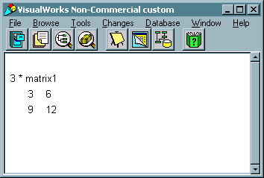

- The Transpose exchanges rows and columns.

transpose
"Returns the transpose of the receiver."

| nrows ncols matrix |
nrows := self rows.
ncols := self cols.
matrix := Matrix2D rows: nrows cols: ncols.
1 to: nrows do: [ :row |
1 to: ncols do: [ :col |
matrix atRow: row atCol: col put:
( self atRow: col atCol: row ).
].
].
^matrix

- Below is an example of transposing matrix.

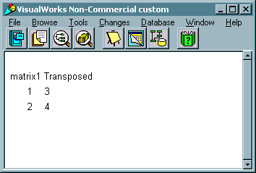
Transcript show: 'matrix1 Transposed'.
(matrix1 transpose) writeToTranscript.

- Vectors are easily represented through the implementation of the Matrix class we have demonstrated, since a vector is nothing more than a single row of a matrix.
- $\begin{aligned} V=\left[V_{1} V_{2} … V_{n}\right], M=\begin{aligned}\left[M_{\text{11}} M_{\text{12}} … M_{1m} | \right]\left[M_{\text{21}} M\text{22} … M_{2m} | \right]\left[⋮ | \right] \\ \end{aligned} \\ \end{aligned}$Recall the product of a vector and a matrix is a vector as follows:

- The following code will create a vector and multiply it by matrix1

vector1 := Matrix2D rows:1 cols:2.
vector1 at: #(1 1) put: 1.
vector1 at: #(1 2) put: 10.
Transcript show: 'vector1'.
vector1 writeToTranscript.
Transcript show: 'vector1 * matrix1'.
(vector1 matrixMult: matrix1) writeToTranscript.

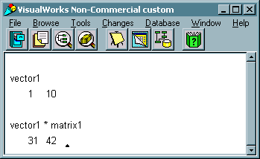

Lecture 18: The Stream Classes

Streams
- Streams provide basic communication between the Virtual machine and the system
- Types of streams
- Semaphores
- Sockets
- Files
- stdin & stdout
- IMPORTANT: The programmer must close all open streams. Smalltalk will not close them for you, as in most compiled languages. The operating system has a limit on the number of open streams, and will quickly run out if the streams are not closed

Important methods for all Streams
- Accessing
- next returns the next object in the stream
- next: anInteger returns the next anInteger number of objects
- contents returns all of the objects in the collection
- close closes the stream
- Ex:

| aStream anObject |
aStream := ReadStream on: #('A' 'B' 'C' 'D').
anObject := Bag new.
anObject add: aStream next.
anObject add: (aStream next: 2).
anObject add: aStream contents.
aStream close.
anObject inspect.

- Writing
- nextPut: anObject places anObject in the stream so that it is the next accessible
- Ex: Generate & write the alphabet to a stream

| aStream|
aStream := WriteStream on: (String new).
65 to: 90 do: [:aNumber | aStream nextPut: aNumber asCharacter].
aStream close.
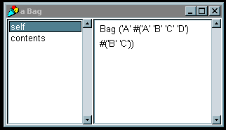aStream inspect.

- 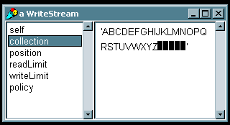nextPutAll: aCollection puts the contents of aCollection into the stream.
- Example: Putting the number 1->10 into a Stream

| aStream aCollection |
aCollection := Array new:10.
1 to: 10 do: [ :aNumber | aCollection at: aNumber put: aNumber].
aStream := ReadWriteStream on: (Array new: 10).
aStream nextPutAll: aCollection.
aStream close.
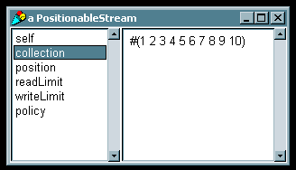aStream inspect.

- Example: Different way to get the same results. Which is the safer way? Which is the more “elegant” way?

| aStream aCollection |
aCollection := Array new: 10.
aStream := PositionableStream on: (aCollection).
1 to: 10 do: [ :aNumber | aCollection at: aNumber put: aNumber].
aStream close.
aStream inspect.

Important methods for Positionable Streams
- Accessing
- position returns the position in the stream
- peek returns the next object without advancing the position
- reset resets the position in the stream
- skip: anInteger skips anInteger positions in the stream
- Ex:

| aStream anObject |
anObject := 'This is a single String'.
aStream := ReadWriteStream on: (String new).
aStream nextPutAll: anObject.
aStream reset.
aStream skip: 2.
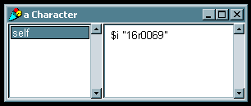(aStream peek) inspect.

Important methods for ReadStreams
- Instance Creation
- ReadStream on: aCollection
- All other positionable stream methods and general methods will work except for ones which write (such as at:put: methods)

Important methods for WriteStreams
- Instance Creation
- WriteStream on: aCollection
- Accessing
- flush write all unwritten information to the stream
- Good “book-keeping” habit to do before closing streams or saving images.
- Similar to ReadStream, can access all methods of more general streams, but cannot read from streams

Important methods for External and File Streams
- Instance creation
- 2 step process- make the filename, then apply the method to the filename. For the entire list of possible methods, refer to LaLonde, or the system browser under Filename->stream creation.

| aStream aFilename |
aFilename := Filename named: ‘yourfile.txt’.
aStream := aFilename writeStream.

- Accessing
- nextNumber: n returns the next n bytes in the stream
- nextString returns the next String from the stream.
- skipwords: nWords advances the position nWords number of words (2 bytes, not to be confused with strings)
- wordPosition returns the position in words
- wordPosition: wp advances the position to wp in words
- Writing
- nextPut: anObject places anObject in the stream so that it is the next accessible
- nextPutAll: aCollection puts the contents of aCollection into the stream.
- Example, writing to a file.

| aStream aFilename |
aFilename := Filename named: 'temp.txt'.
aFilename delete.
aStream := aFilename readWriteStream.
1 to: 20 by: 5 do: [ :aPosition |
aStream wordPosition: aPosition.
aStream nextPut: $D].
aStream close.

Common Mistakes
- Writing a collection to a stream is not the same as writing the contents of the collection.
- Example: What is wrong with this? Shouldn’t we see the number 2 instead of ‘nil’? No, the first object is the collection, the second object is the end of the stream.

| aStream aCollection |
aCollection := Array new: 10.
aStream :=ReadWriteStream on: (aCollection).
1 to: 10 do: [ :aNumber | aCollection at: aNumber put: aNumber].
aStream reset.
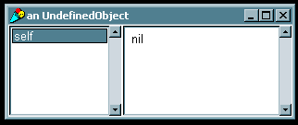(aStream peek) inspect.

Hierarchy

Lecture 19: Matrix Example using Streams
- Recall the Matrix example. Now, rather than getting the matrix from standard in, we will read the matrix from a file. To maintain simplicity, we will keep the rules strict, but to allow for flexibility we will intelligently get the dimensions of the matrix. The rules of the file are as follows:
- One matrix to a file
- The matrix must be complete. That is, all rows must contain the same number of elements
- The matrix will start with ‘[‘ and end with ‘]’.
- Each row will be separated by a carriage return
- Each element will be separated by white space (tabs, cr’s, spaces).
- No element may be negative
- So, using these rules, a 3x3 identity matrix would be represented as below:

[ 1 0 0
0 1 0
0 0 1 ]

- We need two methods, one to read from a file, and one to write to a file. We will add these methods to the Matrix2D class.
- The read method, fromFile: aMatrix is and instance creation method (like new). The method follows a simple parsing algorithm:

Get characters until ‘[‘;
rowCount = 1;
Get nextString;
If nextString = ‘\n’
increase rowCount;
add Collection to Matrix
reset Collection to nil
If nextString is a number then add it to Collection

- This method accomplishes this by reading one character at a time, building up a string to be converted into numbers.
- Since we don’t know how big the matrix will be, we can’t store the elements immediately into the matrix. Instead, each row is read into an OrderedCollection.
- Once the OrderedCollection object is built, the addLast: method is called to add the OrderedCollection object to the matrix. The number of rows is then incremented.
- The following code implements the method as discussed above

fromFile: aName
"Creates a 2D matrix from a file of the name aName"

| aStream aFilename aString aChar aCollection aMatrix|
aFilename := Filename named: aName.
aStream := aFilename readStream.
aChar := aStream next.

"Create the Matrix"
aMatrix := Matrix2D rows:0 cols:0.

"eat up everything until the open bracket"
[ aChar = $[ ]
whileFalse: [ aChar := aStream next].
"matrix has started"
aCollection := OrderedCollection new.
aString := String new.
[ aChar = $] ]
whileFalse: [
aChar := aStream next.
aChar asInteger = 13 "cr"
ifTrue: [
aString size > 0
ifTrue: [
aCollection add:
(aString asNumber).
aString := String new.
].
aMatrix addLast: aCollection.
aMatrix setrows: (aMatrix rows + 1)
cols: (aCollection size).
aCollection := OrderedCollection new.
].
aChar isSeparator "any white space"
ifTrue: [
aString size > 0
ifTrue: [
aCollection add:
(aString asNumber).
aString := String new.
]
].
(aChar isDigit)
ifTrue: [aString := aString,
(aChar digitValue printString)].
].
aStream close.

"Add the last one, since the ']' was on the last line"
aMatrix addLast: aCollection.
aMatrix setrows: (aMatrix rows + 1)
cols: (aCollection size).
aCollection := OrderedCollection new.

^aMatrix

- The method to write the matrix to a file is considerably more simple. A ‘[‘ is written, then each row is written as characters, then a ‘]’ is written.

writeToFile: aName
"Writes the matrix to the file aName. The format is
such that fromFile: can be called to read it back
into a matrix."

| aStream aFilename|
aFilename := Filename named: aName.
aStream := aFilename writeStream.

aStream nextPut: $[.
1 to: (self rows) do: [ :row |
1 to: (self cols) do: [ :col |
((self atRow: row atCol: col) printString)
do: [ :char |
aStream nextPut: char
].
aStream nextPut:$ . "space"
].
row = (self rows)
ifFalse: [
aStream nextPut: 13 asCharacter. "cr"].
].
aStream nextPut: $].
aStream close.

- 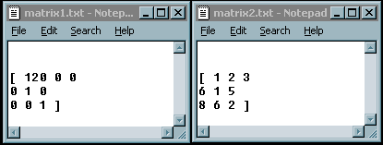To illustrate the use of the new file methods, we will read two matrices from text files (“matrix1.txt” and “matrix2.txt”), then multiply them together. Their product will be written to a file (“matrix3.txt”). Below is a screen capture of the two input text files.

- The code below will now multiply the matrices together and write the product to a file. The code also reads the output file back in and prints it to the Transcript as a form of visual sanity check.

| matrix1 matrix2|
matrix1 := Matrix2D fromFile: 'matrix1.txt'.
Transcript show: 'matrix1'.
matrix1 writeToTranscript.
matrix2 := Matrix2D fromFile: 'matrix2.txt'.
Transcript show: 'matrix2'.
matrix2 writeToTranscript.
(matrix1 matrixMult: matrix2) writeToFile: 'matrix3.txt'.
Transcript show: 'From file: matrix3'.
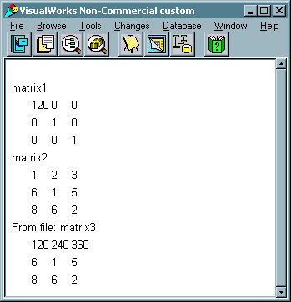
(Matrix2D fromFile: 'matrix3.txt') writeToTranscript.

- The code results in the output file

