Shared Memory Management for VisualWorks

Abstract

Using Shared Memory is a means of optimizing data interchange between applications. The idea is to avoid any communication and transfer overhead for sending and receiving data. Instead, data are placed in a memory area where associated applications have direct read and write access.
The purpose of this project is to revive the discussion about this approach, with emphasis on multi-core computing, and explore the benefits it may provide for VisualWorks applications.

Bio:
Holger Guhl is with Georg Heeg e.K. since 1993. He is Senior Consultant and Certified Scrum Master, and has been on development and consulting projects since 1995. He made his first studies about multi-core processing with Polycephaly in 2009, after experiencing heavy time consumption in a challenging project.
Table of Contents

1 Motivation 3
1.1 What is Shared Memory? 3
1.2 Why Shared Memory? 3
1.3 Polycephaly 3
2 Personal Experience 4
3 Project Plan 5
4 Application Scheme 6
5 Package SharedMemory 7
6 Package RemoteSemaphore 7
7 Package SharedMemory-ExampleApp 9
8 Time Profiles 9
8.1 Shared Memory overhead 9
8.2 UDP Message/Reply Roundtrip 9
8.3 SharedMemory unprotected read / write / write+read 10
8.4 Encoding/decoding examples 10
8.5 Polycephaly Use Cases 11
8.6 Polycephaly Use Cases With Shared Memory Data Exchange 12
8.7 Use Cases with Shared Memory Command And Data Exchange 13
9 Fractal Explorer 14
10 Conclusions 16

Motivation

What is Shared Memory?
In general, every program must allocate memory to temporarily store data. Reclaiming memory reserves space on the so-called heap. This space is for exclusive use of the reclaiming program. Shared access is inhibited, i.e. programs may not read or write the heap memory reclaimed by other programs.
Shared memory is a concept and feature supported on all operation systems. It explicitly allows shared access of memory for different programs. On Windows, shared memory is backed by the system page file. Reclaiming shared memory means reserving space in the page file.
Shared memory was a preferred approach back in the 80ies and 90ies. There are a couple of reasons why it has become a bit “out of fashion”:
- Shared memory makes sense only for applications running on the same host. There is no such thing like cross-host shared memory.
- Architectures are designed for networks and applications run on different hosts. They cannot share memory.
- Internet and b2b applications interchange with HTTP and web services.
- Increasing processor and general hardware speed make explicit data transfer bearable.

This makes clear why that concept seems to be “legacy”.

Why Shared Memory?
With upcoming multi-core computers a new development has started that might be a platform to revive the shared memory approach. There is a strong demand to “make more” from those many CPUs that even consumer-level laptops have.

Smalltalkers have discussed the idea of a multi-core image that could concurrently run threads on many CPUs. The realization of this idea demands technological changes in the architecture of Virtual Machines and Images. The necessary changes are far beyond Cincom’s road map, and this project has nothing in common with this idea.

Polycephaly
An attractive approach is Polycephaly or its more recent version Polycephaly2 (now MatriX): One VisualWorks image works as master image and starts multiple clones of itself (called drones) in order to build a “computing team”. Drone images are automatically distributed by the OS over available CPUs. The master image sends Smalltalk blocks to drone images which evaluate them and answer the result. Both blocks and results are exchanged between master and drone images via sockets.
Example:

| drones result |
drones := VirtualMachines new: 4.
result := drones do: '[:a :b | a + b]' with: #(1 2 3 4 5) with: #(5 4 3 2 1).
result = #(6 6 6 6 6)

The Polycephaly framework takes over most of the work to distribute actions over drones as available.
Cincom and Heeg developers have already shown that certain kinds of problems benefit from the extra power and finish in less time. For instance, the computation of Mandelbrot figures is ideal for distribution over many drones, because the math calculation effort is much more than the result objects to interchange. An implementation at Heeg was made significantly faster with use of Polycephaly:

Setup | Iterations | Exec. Time
Single image for calculation and displaying | 37177 | 1,423 sec
1 drone image for calculation, display in master image | 37177 | 591 sec
8 drone images for calculation, display in master | 37177 | 184 sec

This means speeding up by a factor of 1,423 / 184 = 7.7 !

A disadvantage of the multi-drone approach is that it is not well suitable for tasks which need much communication. If there is much communication necessary to distribute the tasks over drones, synchronize the work and – last not least – answer the result, then it is easily possible that all the performance gains are devoured by the communication overhead.

Shared memory could be a solution, and it’s one of the objectives of this project to find out how much the performance can increase.

Personal Experience
Once I had a project about software assessment. All code (bundles, packages, classes, method, etc) of a given project had to be analyzed and metrics had to be applied. The result was exported in XML format. Normal test projects were analyzed within acceptable time:

Project | Classes | Methods | Lines of code | Exec.time
- Analyzer software itself | 151 | 668 | 5,893 | 00:00:08
- Customer test project | 1,227 | 11,992 | 97,274 | 00:02:27
- Base-VisualWorks | 2,118 | 31,501 | 236,932 | 00:28:45
- Other customer project | 6,411 | 100,872 | 243,133 | 01:30:53

But the customer projects were huge and the software analysis took 4 hours and more to finish!

My idea was to speed up using more CPUs, each running a Polycephaly drone image for subtasks of the entire analysis. Options for task distribution were perfect: Every unit of code containment (package, class, method) could be made its own distributable analysis task. Unfortunately, the result could not be produced by helper images alone, but the specified final output needed filtering of duplicates and merging of partial results. This made necessary to report a lot of structured information back to the controller or master image.
Communication overhead consumed all time gains from using multiple CPUs. The results were disappointing. The first implementation was even slower than using one image only. The simplest example (project 1 in the table above) took 24 seconds! That was 3 times as long as the original implementation. By minimizing the result communication I could bring the execution time down to 8 seconds which is the same time as using a single CPU.
Obviously, the demand for much communication is the killer argument against the multi-image approach. The primary problem is the number of communication events, not the size of transmitted data.

Nevertheless, one may ask whether more efficient transmission techniques could pave a way out of the communication overhead trap. The purpose of this study is to investigate the potential benefit of using shared memory.

Project Plan
This is an exploration study. The intended implementation will cover just the minimum to find out whether the execution time is fast and how much benefit can be expected. The exploration platform is Windows, no other platform will be investigated so far. For comparison purposes we’ll implement Polycephaly2 use cases. This means: A master image sends Smalltalk blocks to drone images which evaluate them and answer the result. Both blocks and results are exchanged between master and drone images via sockets. This is a reasonable choice, because socket transmission is very common and typically fast. The transport abstraction layer above sockets is XStreams which uses very efficient marshaling algorithms.

Planned components
Here is an overview of the system architecture:

Windows Operation System
SharedMemory-Profiling
uses
SharedMemory-ExampleApp
runs
SharedMemory
SharedMemory-Win32
uses
uses
RemoteSemaphores
Win32MessageSending
uses

Short descriptions:

- SharedMemory implements the domain classes to organize and access shared memory. The SharedMemory class uses RemoteSemaphore to serialize shared memory access of multiple images.
- SharedMemory-Win32 is the platform dependent implementation of allocating shared memory on Windows.
- RemoteSemaphores implements semaphores that are distributed over multiple processes (images, programs, executables, not Smalltalk Processes). For our purposes it’s sufficient to have semaphore pairs: One half is created by a master image, the counterpart lives in another image and mirrors the blocking state. There will be a class hierarchy to implement various techniques of communicating between semaphores.
The preferred approach of semaphore communication is sending OS events. Sending events is a fast means of communicating “things” between programs. They are delivered via the Virtual Machine and the I/O processing loop, and there is basically no overhead. The delivery is timely and works pretty similar to semaphore signals.
- Win32MessageSending is the platform dependent implementation of sending semaphore communication events on Windows.
- SharedMemory-ExampleApp implements use cases for computation tasks. Polycephaly is used to start and coordinate multiple images as well as requesting tasks and answering results. The time consumption of these tasks are the reference for the comparison. Since the focus is on hsared memory execution time, we’ll have hybrid use cases, with Polycephaly task requests and result transmission through shared memory. An extra “shared memory shell” will implement a “pure” shared memory solution which sends both task requests and results through shared memory.
- SharedMemory-Profiling implements the time measurement and reporting engine.

Application Scheme
The general design serves the idea to connect multiple images running on different CPUs on the same host. We stick to the simple understanding that there is one master image which controls a number of drone images. One basic assumption is that drone images communicate with the master only and not with other drones. So we can adopt a simplified view of two images: master and drone.

CPU 2
DRONE
Shared Memory
CPU 1
MASTER
Remote Semaphore

Master and drone image run on different CPUs. Data is exchanged via Shared Memory. Access control to ensure mutual exclusive access is provided by RemoteSemphores.

Package SharedMemory
This package implements the domain to organize and access shared memory. The necessary code is surprisingly simple. Basically, we need only the class SharedMemory. It does what the name says: Allocation of and access to shared memory which is provided by the Operation System and shared by multiple processes. Processes mean different applications, programs, executables, and not threads in one image. While the design is open enough to connect applications of different programming languages, the focus is on VisualWorks images that shall share memory.
The class implements both server and client behavior: The owner (server) makes the initial allocation request to the OS for shared memory; clients request a shared access handle to the installed shared memory. Full read-write access is granted for all processes, since the focus is on interchanging data in both directions. The shared access for multiple parallel processes is protected by a RemoteSemaphore to ensure synchronized, conflict free access.

Class Smalltalk.OS.SharedMemory
Instance Variables
name | String | identifies shared memory on OS level, other application refer to that name if they request shared access
size | Integer | shared memory size in bytes
accessLock | RemoteSemaphore | serialize concurrent shared memory access
baseAddress | CPointer | shared memory base address
handle | CPointer | a file handle, returned by the OS on allocation or shared access request
xif | Win32SharedMemory | concrete ExternalInterface to talk with the OS to allocate and access shared memory

The shared variable #Registry keeps all instances.

Package RemoteSemaphore
If multiple images want to access shared resources, we need protection against concurrent access. Like an in-image semaphore which protects a critical section and guarantees synchronous access to shared resources, we need something like a cross-image or remote semaphore that provides the same service for multiple images. This is the task of class RemoteSemaphore.

Class Smalltalk.RemoteSemaphore
Instance Variables
identifier | Integer | identifies the semaphore in multiple images
localSemaphore | Semaphore | realizes blocking effects inside of the image

The shared variable #KnownSemaphores keeps all instances.

The concept is easy: One RemoteSemaphore synchronizes two images (or one image and another program). One of the images is regarded the master or owner, which creates the semaphore, the other image is a client which keeps a mirror instance linked to the master. The idea is that the protocol keeps both instances of this linked pair in sync:
- #signalLocal and #waitLocal simply signal or wait with a normal Semaphore.
- #signalRemote sends a message to the remote pair which in turn does simple #signalLocal.
- #waitRemote is a synchronous message send: First, a message is sent to the remote pair to request a blocking state, i.e. any excess signals are reset so that the next #waitLocal in the remote image meets a blocked semaphore. The remote image processes the message and sends a result message which tells whether the required state could be achieved. If so, the requesting image can continue, otherwise we have an exception that needs to be handled, e.g. by repeating the request.
- #signal triggers the two actions #signalRemote and #signalLocal.
- #wait invokes #waitRemote and #waitLocal.

There are many ways to implement the transmission of messages. That’s the reason why RemoteSemaphore is an abstract class. Subclasses should implement the concrete approach, e.g. socket based communication or using Operation System means for synchronization. The latter is not easy, because on Windows this involves blocking and continuing threads. For VisualWorks, this is not feasible, because there is only one thread (the Virtual Machine) which must not be blocked.

The approach chosen here is sending Operation System events, implemented with the RemoteSemaphore subclass EventBasedSemaphore. The advantage is that it is easy to implement, events are sent very fast and no special communication line to interchange signals is necessary. Sending special semaphore events can be done with OS functions. Incoming events are received via the Virtual Machine and passed over to InputState. The default event processing machinery finally delivers the events to specialized processors.
We have built an implementation for Windows only, but the basic concept is available on every OS, and it shouldn’t be a big deal to implement Unix or Mac OS solutions.
On Windows, events are sent with OS function SendMessage(). The event receiver is specified with a handle of the target window. The event payload has the structure:
struct {
long kind;
long hWnd;
long message
long wParam
unsigned long lParam;
} ST_EventRecord

Four components are important:
- hWnd specifies the receiver of the event.
- message is assigned with an application defined message code greater than WM_APP (=0x8000).
- wParam and
- lParam are used as parameters that are evaluated as suitable for the message.

The class to implement a communication interface based on sending and receiving OS events is SemaphoreEventRelay. It has the knowledge of how to connect to other images and address remote semaphores. It serves as communication center for all outgoing and incoming remote semaphore messages.
We have relay instances in connected images. One is regarded the master relay, others are clients. The typical connection pattern for this (multi-core image) study is to tell clients the address (window handle) of the master relay. This is given with a command line parameter while starting a drone image. As soon as a client starts up, it starts its own semaphore event relay and sends an event message to connect to the master. The event tells the client relay handle. Now master and client know the addresses and can send semaphore events for creating a remote pair, #signalRemote, #waitRemote, etc.
Incoming events addressed to a relay are dispatched as UnknownEvent to the underlying relay window. Usually, UnknownEvents are ignored, but relay windows subscribe to its delivery. For each such event the method #windowEvent:from: is sent and in case of UnknownEvent we delegate to #handleUnknownEvent:. If the message code in the event is in the range of application defined WM_APP messages for remote semaphores, then it’s finally processed with #handleSemaphoreMessage:wParam:lParam:. This method identifies the addressed EventBasedSemaphore instance according to wParam and lParam parameters and calls the semaphore method specified by the message code of the event.

Package SharedMemory-ExampleApp
This package holds the all the code for setting up the “system” and running Polycephaly and Shared Memory use cases, and profiling the performance. The main tasks are:
- Install Shared Memory
- Start Polycephaly drone image. We need only one for profiling data exchange.
- Start Drone Client: Let the drone start a client which uses the master’s SharedMemory.
- Start Drone Command Service: Let the drone start a service to accept and process commands sent via SharedMemory.
- Run Polycephaly and Shared Memory use cases and collect profiles.

Time Profiles
For comparing performance of Shared Memory we have measured a couple of basic transmission tasks. The focus is on transferring bytes or Arrays of Integer. “Real” applications might need to interchange more complex data, but with proper encoding this can always be reduced to simple byte transfer. Measurements were always taken as average of a series of 10 repetitions. Time values are expressed in microseconds (µs).

Shared Memory overhead
First let’s see some facts about plain Shared Memory performance.

 | Time (µs)
SemaphoreEventRelay connect client to master | 123
SemaphoreEventRelay Mutex Roundtrip | 117
Table 1: Shared Memory Overhead
The time to connect is not significant, since that happens only once during startup. The time for „mutex roundtrip“ covers sending the #waitRemote message, the time to process the message on the remote side and sending the (synchronous) answer message from the remote side.

UDP Message/Reply Roundtrip
For determining whether OS message sending is a good choice regarding speed, a second relay class using socket transfer was implemented. The time consumption for sending a synchronous query/reply message pair is:
 | Time (µs)
Message/Reply Roundtrip | 399
Table 2: UDP Message/Reply Roundtrip
This shows that sending OS messages is pretty fast. It’s nearly 4 times faster than using UDP.

SharedMemory unprotected read / write / write+read
This scenario measures raw read/write access to shared memory.

Read bytes | Time (µs) | Write bytes | Time (µs) | Read+write | Time (µs)
<= 1,000 | <= 1 | 1,000 | 1 | 1,000 | 1
10,000 | 3 | 10,000 | 1 | 10,000 | 3
100,000 | 53 | 100,000 | 8 | 100,000 | 23
1,000,000 | 509 | 1,000,000 | 80 | 1,000,000 | 343
Table 3: SharedMemory unprotected access

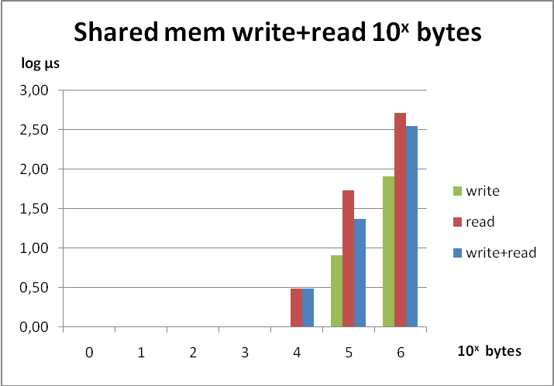
Image 1: Shared memory raw read/write performance

Encoding/decoding examples
These figures above look extremely fast. But that’s only for byte transfer. Let’s see how much we need for simple encoding and decoding.
Simple encoding/decoding example
This scenario measures time needed to encode an Array of Integer as UninterpretedBytes and decode back to Array.

Array to UninterpretedBytes | Time (µs) | UninterpretedBytes to Array | Time (µs)
10 | <= 1 | 10 | < 1
100 | 4 | 100 | 3
1,000 | 38 | 1,000 | 27
10,000 | 380 | 10,000 | 273
100,000 | 4,187 | 100,000 | 2,670
1,000,000 | 42,220 | 1,000,000 | 27,772
Table 4: Simple encoding/decoding
BOSS encoding/decoding
Here we measure the time needed to encode an Array of Integer with BOSS and decode back to Array. BOSS (Binary Object Storage System) is a VisualWorks serializer framework to encode arbitrary complex objects into a binary format.

encode Array of size | Time (µs) | decode Array of size | Time (µs)
1 | 51 | 1 | 21
10 | 53 | 10 | 18
100 | 79 | 100 | 20
1,000 | 371 | 1,000 | 43
10,000 | 3,050 | 10,000 | 289
100,000 | 30,410 | 100,000 | 2,605
1,000,000 | 308,082 | 1,000,000 | 29,925
Table 5: BOSS encoding/decoding
This shows that it’s worth to have special encoding for primitive data structures which can be easier encoded than with BOSS.
Still the numbers are promising. Let’s see how that works in full communication.

Polycephaly Use Cases
We have chosen Polycephaly as “competitor”. That’s fair because the basic transmission is via sockets, which is a fast and commonly used technique. Marshalers for any kind of objects are very efficient. For the comparison of Array transmission, Polycephaly and Shared Memory use similar code.

Polycephaly communication overhead
 | Time (µs)
Request to evaluate the empty block = [ ] | 12,519
Table 6: Polycephaly communication overhead
Polycephaly requests
request bytes | Time (µs) | Request Array of size | Time (µs)
10 | 9,387 | 10 | 8,185
100 | 8,499 | 100 | 9,387
1,000 | 8,327 | 1,000 | 12,001
10,000 | 10,478 | 10,000 | 25,702
100,000 | 21,463 | 100,000 | 166,141
1,000,000 | 123,933 | 1,000,000 | 1,518,115
Table 7: Polycephaly requests
The measured time is almost the same for request size up to 10,000 bytes. Larger than that, size matters. This is clearer in this graphic which shows a constant overhead of roughly 10⁴ µs and affirms the time value measured for profiling the empty block.

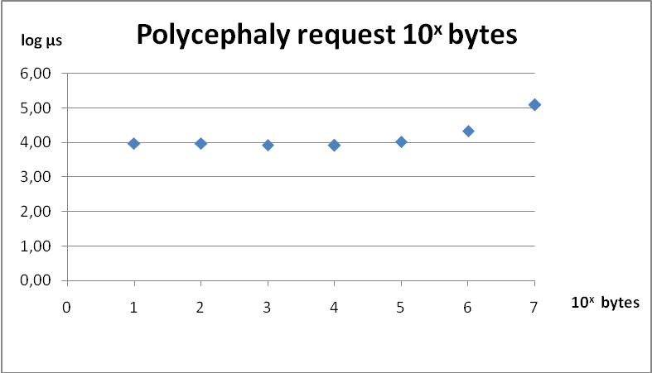
Image 2: Polycephaly overhead in bytes requests

Polycephaly Use Cases with Shared Memory Data Exchange

Polycephaly requests, write+read result via protected shared memory
request bytes | Time (µs) | factor | request Array of size | Time (µs) | factor
1 | 16,434 | 1.8 | 1 | 17,133 | 2.4
10 | 15,425 | 1.6 | 10 | 18,281 | 2.2
100 | 15,346 | 1.8 | 100 | 17,277 | 1.8
1,000 | 15,344 | 1.8 | 1,000 | 18,327 | 1.5
10,000 | 15,324 | 1.5 | 10,000 | 18,010 | 0.7
100,000 | 15,341 | 0.7 | 100,000 | 23,810 | 0.1
1,000,000 | 17,883 | 0.1 | 1,000,000 | 104,050 | 0.1
Table 8: Polycephaly requests, result via protected shared memory
Using shared memory for exchanging results can slow things down! Obviously, the overhead for synchronization with remote semaphores is too much when transmitting tiny packets. Better performance can be seen with packets of size larger than 100 kB or Array of size 10,000. Performance gains of 90% are possible with large packets.

Polycephaly command, write+read result via unprotected shared memory
request bytes | Time (µs) | factor | request Array of size | Time (µs) | factor
1 | 15,739 | 1.7 | 1 | 13,526 | 1.9
10 | 13,263 | 1.4 | 10 | 13,662 | 1.7
100 | 14,363 | 1.7 | 100 | 14,736 | 1.6
1,000 | 14,345 | 1.7 | 1,000 | 14,492 | 1.2
10,000 | 14,453 | 1.4 | 10,000 | 15,251 | 0.6
100,000 | 14,416 | 0.7 | 100,000 | 22,278 | 0.1
1,000,000 | 15,152 | 0.1 | 1,000,000 | 99,906 | 0.1
Table 9: Polycephaly command, result via unprotected shared memory
The picture is slightly better when synchronization is not necessary. Using Polycephaly command transfer can often run without synchronization. If the command to be processed write the result into shared memory right before returning to the master image, then the plain return can be taken as signal that shared memory can be accessed safely.
Still there is no improvement for small packages below 10,000 bytes or Array of 1,000 elements. Given these numbers it does not pay off to go without semaphores.

Use Cases with Shared Memory Command And Data Exchange
The picture changes drastically when using fast shared memory communication also for the request, rather than sending the request via Polycephaly.
The architecture for this is simple: A drone connects to the master image and listens for commands communicated via shared memory. The connection is synchronized with a remote semaphore. The master sends a command and waits for the semaphore to signal. The drone reads the command from shared memory, evaluates the request, writes the result into shared memory and finally signals the remote semaphore. The master can continue and reads the result from shared memory. This gives us very fast results:

Shared memory command, protected write + unprotected read
request Array of size | Time (µs) | Polycephaly time (µs) | factor
10 | 307 | 8,185 | 0.04
100 | 312 | 9,387 | 0.03
1,000 | 397 | 12,001 | 0.03
10,000 | 1,372 | 25,702 | 0.05
100,000 | 10,604 | 166,141 | 0.06
1,000,000 | 99,093 | 1,518,115 | 0.07
Table 10: Shared memory command, protected write + unprotected read

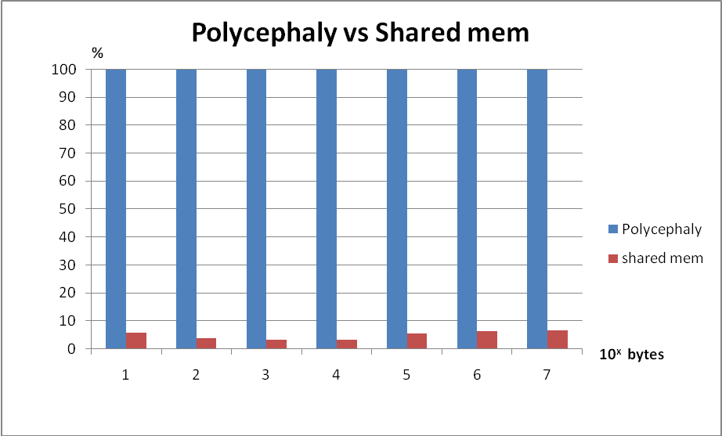
Image 3: Polycephaly vs Shared memory performance
The factor compares shared memory performance with the measured values obtained for basic Polycephaly requests shown in Table 7: Polycephaly requests. These figures suggest a maximum reduction by 97%.
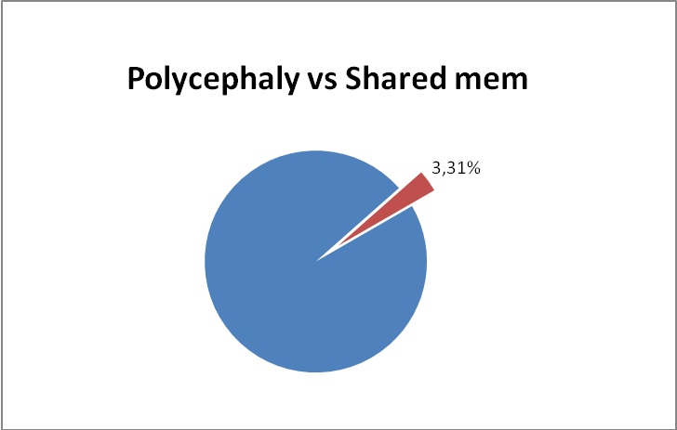
Image 4: Polycephaly vs Shared memory performance

Fractal Explorer
One use case was using Shared Memory to exchange data in “Fractal Explorer”, a Heeg application for calculating fractals like Mandelbrot sets. The implementation uses Polycephaly. The task is ideal because the entire area to be displayed can be divided into smaller tiles, each given to a Polycephaly drone. The effort to compute the function is pretty high, due to thousands of iterations, each doing simple math on complex numbers. It’s classical number crunching. Opposed to that the result to report back to the displaying machine is moderate. The result is an Array of Integer for each tile.
Example:
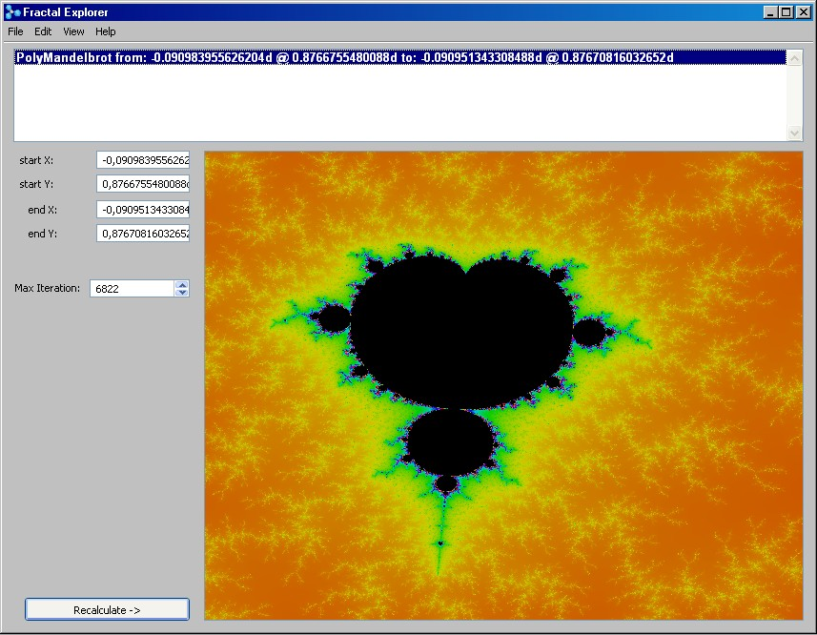
Image 5: Fractal Explorer example
This example was produced on a dual core laptop. The master image engaged 2 Polycephaly drone images running on different CPUs to help the task.
The calculation is dependent on the image size. To be more exact, the effort depends on the iterations performed in the fractal calculation. But the iterations value increases with the image size.
Some samples:

Image size | Time (seconds) | Result Arrays | Average size | Total size
191 @ 186 | 10 | 16 | 2,316 | 37,050
385 @ 324 | 40 | 72 | 1,817 | 130,808
627 @ 491 | 109 | 180 | 1,794 | 322,926
Table 11: Fractal Explorer data transmission requirements
The work for creating the largest sample image size 627 @ 491 is split into calculations for 180 tiles, each returning an Array with average size of 1,794 integers. The measured time and result size values are logged by the application itself.

How fast would it be if we could transfer those Arrays via shared memory? How much time could be saved?
The idea to use Fractal Explorer was born while watching colleagues implementing the calculators with Polycephaly, with the assumption that the overall load is high. The measured result sizes were surprisingly low. In the light of shared memory performance measured so far, it seemed wiser to check the potential benefit, before going into implementing a shared memory transfer scheme.

Estimation of possible time benefit
Let’s assume that we use the fastest transfer shown in this paper “Shared memory command, protected write + unprotected read”. This scenario can transfer an Array of size 1,000 within 397 µs.
Shared memory command, protected write + unprotected read
request Array of size | Time (µs) | factor
1,000 | 397 | 0.03

With an average size of 2,000 elements per Array, the plain transfer time for the largest sample would be
180 * 2 * 397 µs = 142,920 µs ≈ 143 ms
The performance factor 0.03 (see Table 10: Shared memory command, protected write + unprotected read) tells that the Polycephaly transfer time for the same amount of data would be
142,920 µs / 0.03 = 4,764,000 µs = 4,764 ms ≈ 5 seconds
This is affirmed by the Polycephaly measurements. If we pick a time value between 12,000 µs for 1,000 elements, and 25,700 µs for 10,000 elements, e.g. 18,000 µs, then we get
180 * 18,000 µs = 3,240,000 µs
The basic numbers are impressive: The estimated Polycephaly data transfer time of 5 seconds can be reduced to 143 milliseconds, thus essentially annihilating that time consumption.

Outline of shared memory transfer scheme
A Polycephaly request is a Smalltalk block sent to a drone image. The drone evaluates the block and returns the result via a socket connection. Changing to shared memory result transfer is simple: The request block must be designed such that the result is written to shared memory, and the final block result must be cheap, e.g. nil, true, false, etc. The sender of the request block reads the real result from shared memory.

Although this kind of refactoring is cheap, the found numbers do not encourage reworking the implementation. The estimation promises a performance gain of 5 seconds from 109 seconds total execution time (math calculation and data transfer), in other words 5,45% less time consumption.
This does not justify implementing shared memory transfer. The idea was dropped before wasting time.
The reason is that fractals are indeed the perfect example for Polycephaly: Much calculation, full stress for engaged CPUs and minimal overhead for small result communication.

Conclusions
The good news is:
Shared Memory can be used to speed up communication significantly.

The practical experience of this study has shown that massive transmission of simple data can be done in a fraction of time needed with TCP-based transport. The potential reduction of data transmission time 97% is impressive. That opens new perspectives for applications that suffer from high load for data exchange.

Another good news is that TCP is not bad if the data to be transmitted is moderate. One could even say that using shared memory is not worth the implementation effort if the amount of interchanged data is moderate.

This study is focused on transmission of simple data (bytes, strings, arrays with simple data). Another use case could be keeping shared objects in shared memory. These objects should also be simple. With the nature of Smalltalk implementations where garbage collectors steadily move objects in memory, you simply cannot “move” a complex object structure (e.g. a graph) into shared memory. But maintaining a shared matrix with simple data cells in shared memory could gain some time profit.
The maximum gains are achievable if interchanged data are simple. As long as we cannot put our Smalltalk object model over shared memory, the whole thing boils down to transmitting bytes and strings. The more effort is needed to encode objects to bytes and back from bytes to its original shape, the less time is saved. Some figures for BOSS encoding/decoding of simple structures have been presented. More complex object will take more time to encode and definitely more to decode. The overhead for this encoding consumes time that must be fed by shared memory transmission gains.

Developers who want to give the shared memory approach a try, should determine the encoding overhead and then decide whether the expected time benefit still pays off.
After all, it’s a matter of trying and measuring. This study may be helpful for first estimations.

